15. GFDM vs OFDMA Comparison using MATLAB

1. AIM
To compare GFDM (Generalized Frequency Division Multiplexing) and OFDMA (Orthogonal Frequency Division Multiple Access) in terms of spectral efficiency and time-domain waveforms using MATLAB simulation.

2. SOFTWARE REQUIRED
- MATLAB R2018 or above
- Signal Processing Toolbox (optional)

3. THEORY (Simple)
GFDM
- GFDM is a flexible multicarrier modulation technique used in 5G research.
- Uses:
  - M subcarriers
  - K subsymbols
- Uses circular-pulse shaping → lower out-of-band emissions (OOBE).
- Suitable for IoT/5G low-latency apps.
OFDMA
- OFDMA is a multi-user version of OFDM.
- Uses strict orthogonality between subcarriers.
- Advantages: low complexity, efficient FFT processing.
- Used in LTE, WiFi, 5G.

4. PROCEDURE (Simple Steps)
- Set simulation parameters:
number of subcarriers, subsymbols, modulation (QAM).
- Generate random bits for transmission.
- Map bits → QAM symbols.
- GFDM:
  - Reshape symbols (K × M)
  - Apply pulse shaping & circular convolution
  - Generate GFDM time-domain signal
- OFDMA:
  - Perform IFFT
  - Generate OFDM signal
- Plot time-domain signals.
- Compute and compare spectral power.
- Display results.

5. PSEUDOCODE (Simple)
Initialize M subcarriers, K subsymbols
Generate random bits
Map bits to QAM symbols

# GFDM
Reshape symbols into K × M block
Apply RRC pulse shaping
Perform circular pulse shaping
Generate GFDM waveform

# OFDMA
Insert QAM symbols
Perform IFFT
Generate OFDM waveform

Plot both signals and spectra
Compare outputs

Code
clear; clc; close all;

%% PARAMETERS
N_subcarriers = 8; % Number of subcarriers
N_subsymbols = 4; % Number of subsymbols per subcarrier
M = 4; % QPSK modulation
sps = 8; % Samples per symbol for pulse shaping

slice_names = {'OFDMA','GFDM'}; % For legend

%% GENERATE RANDOM DATA
data = randi([0 M-1], N_subcarriers, N_subsymbols);

% QPSK mapping: 0->1+1j, 1->1-1j, 2->-1+1j, 3->-1-1j
data_mod = exp(1j*2*pi*data/M);

%% -------------------- OFDMA WAVEFORM --------------------
ofdm_signal = zeros(1, N_subcarriers*N_subsymbols*sps);
for k = 1:N_subcarriers
sym_up = upsample(real(data_mod(k,:)), sps); % upsample for time resolution
t_index = (1:length(sym_up)) + (k-1)*length(sym_up);
ofdm_signal(t_index) = ofdm_signal(t_index) + sym_up .* cos(2*pi*(k-1)/N_subcarriers*(0:length(sym_up)-1));
end

%% -------------------- GFDM WAVEFORM --------------------
beta = 0.25; % Roll-off factor
span = 4; % Filter span in symbols
rc_filter = rcosdesign(beta, span, sps); % Raised Cosine filter

gfdm_signal = zeros(1, N_subcarriers*N_subsymbols*sps);
for k = 1:N_subcarriers
sym_up = upsample(real(data_mod(k,:)), sps); % upsample
filt_sym = conv(sym_up, rc_filter, 'same'); % apply pulse shaping
t_index = (1:length(filt_sym)) + (k-1)*length(filt_sym);
gfdm_signal(t_index) = gfdm_signal(t_index) + filt_sym .* cos(2*pi*(k-1)/N_subcarriers*(0:length(filt_sym)-1));
end

%% -------------------- PLOTS --------------------
figure;

% a. Random QPSK data
subplot(3,1,1);
stem(real(data_mod(:)),'filled');
title('Random QPSK Data for Subcarriers and Subsymbols');
xlabel('Symbol Index'); ylabel('Amplitude'); grid on;

% b. OFDMA waveform
subplot(3,1,2);
plot(ofdm_signal,'LineWidth',1.5);
title('OFDMA Waveform (Time Domain)');
xlabel('Sample Index'); ylabel('Amplitude'); grid on;

% c. GFDM waveform
subplot(3,1,3);
plot(gfdm_signal,'LineWidth',1.5);
title('GFDM Waveform with Pulse Shaping (Time Domain)');
xlabel('Sample Index'); ylabel('Amplitude'); grid on;

OUTPUT:
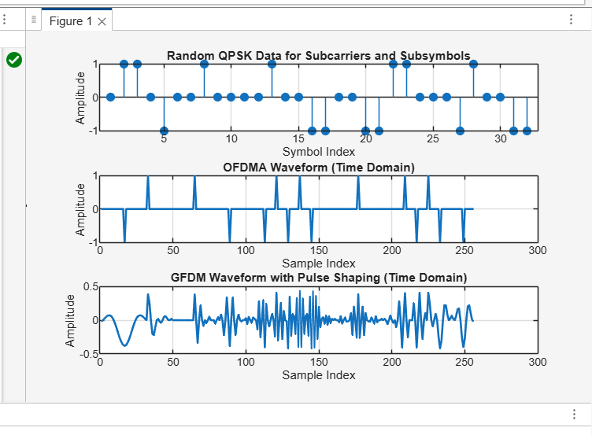
Result:
- Time-domain signal: GFDM is smoother; OFDMA is more rectangular.
- Spectrum: GFDM has lower side lobes (better spectral efficiency); OFDMA has higher side lobes.
- Conclusion: GFDM is more flexible and spectrally efficient, while OFDMA is simpler to implement.

